

AMITY UNIVERSITY BENGALURU

**SOURCE CODE MANAGEMENT**

**LAB MANUAL**

***SUBMITTED BY: SUBMITTED TO:***

***JAHNAVI.M Dr. MONITH KAPOOR***

***A86605224180***

***B.TECH IN CSE***

|  |  |
| --- | --- |
| **SI.**  **NO** | **INDEX** |
| **1.** | **Basics of Linux** |
| **2.** | **Introduction-Git Bash** |
| **3.** | **Git Bash And Git Hub** |
| **4.** | **File Creation with commit and push**  **command** |
| **5.** | **Branches Creation** |
| **6.** | **Merge Request** |
| **7.** | **Open and Close Pull Request** |
| **8.** | **Complete Git Process** |

EXPERIMENT-01:

• **Basics Of Linux:**

1.What is Linux ?

Linux is a family of free and open-source operating systems based on the Linux kernel. Operating systems based on Linux are known as *Linux distributions* or *distros*. Examples include Debian, Ubuntu, Fedora, CentOS, Gentoo, Arch Linux, and many others.

1. **Linux Distributions (Distros)**

Different versions of Linux tailored for various needs:

* + **Ubuntu** – User-friendly, great for beginners.
  + **Debian** – Stable and well-tested.
  + **Fedora** – Latest features, cutting-edge.
  + **Arch Linux** – Lightweight and customizable.
  + **CentOS / RHEL** – Used in enterprise environments.

1. **Linux File System Structure**

Linux follows a hierarchical structure:

* 1. bin → essential binary programs
  2. etc → configuration files
  3. home → user directories
  4. root → root user’s home directory
  5. var → variable data (logs, etc.)
  6. tmp → temporary files
  7. usr → user-installed software

1. **Basic Linux Commands**

**Command Description**

|  |  |
| --- | --- |
| ls | List files in a directory |
| cd | Change directory |
| pwd | Print working directory |
| mkdir | Make a new directory |
| rm | Remove files/directories |
| cp | Copy files/directories |
| mv | Move or rename files |
| cat | Display file content |
| sudo | Execute a command as superuser |
| man | Show manual/help for a command |

1. **File Permissions** 
   * Linux controls file access with permissions.
   * Use ls -l to view them (e.g., -rwxr-xr--).
   * Modify with chmod, chown, or chgrp.

1. **Package Management** 
   * Install/update software using package managers:
     + - **Debian/Ubuntu**: apt (e.g., sudo apt install

package-name)

* + - * **Red Hat/Fedora**: dnf or yum o**Arch Linux**: pacman

1. **Shell and Terminal** 
   * The **shell** interprets commands (e.g., **bash**, **zsh**).
   * Terminal is where you type the commands.

1. **Users and Permissions** 
   * + Regular users vs. root (superuser).
     + Manage users with adduser, usermod, and passwd.

Experiment-02:

* + - **Introduction -Git Bash** 🚀 What Is Git Bash?

Git Bash is a command-line tool for Windows that provides:

* + - Git command-line tools
    - A Bash (Unix-style) shell
    - A way to run shell commands similar to those used in

Linux/macOS

It's especially useful for developers using Git on Windows who want a Unix-like experience.

✅ Key Features**:**

1. Bash Emulation:

* + - * Bash (Bourne Again SHell) lets you run Linuxstyle commands (e.g., ls, pwd, rm).
      * This makes it easier to follow tutorials written for Linux/macOS.

2. Git Integration:

oYou can run Git commands like git clone, git status, git commit directly in Git Bash. oUseful for version control and managing code repositories.

3. Cross-Platform Compatibility:

oLets Windows users interact with remote Linux servers or repositories more easily. 🖥️ How to Install Git Bash:

1. Go to [https://git-scm.com](https://git-scm.com/)
2. Download the installer for your OS (choose Windows).
3. Run the installer and select “Git Bash” when prompted about default terminal.
4. After installation, right-click anywhere and choose “Git Bash Here” to open the terminal.

💡 Common Commands in Git Bash**:**

|  |  |  |
| --- | --- | --- |
| Command | Description | |
| ls | List files and directories | |
| pwd | Print current directory path | |
| Command | Description |
| cd | Change directory |
| mkdir myfolder | Create a new folder |
| rm filename | Remove a file |
| git init | Initialize a new Git repository |
| git clone URL | Clone a repository from  GitHub |
| git status | Show current Git status |
| git add . | Stage all changes |
| git commit -m "message" | Commit staged changes |

🔧 Use Cases:

* + - Managing Git repositories
    - Running shell scripts
    - Navigating your project with Unix-style commands
    - Automating development tasks

Experiment-03:

* + - **Git Bash And GitHub**

🧠 What is Git?

Before connecting GitHub and Git Bash, it’s important to know:

* + - Git is a version control system to track changes in code.
    - GitHub is a hosting service for Git repositories.
    - Git Bash lets you use Git on Windows with Linux-style commands.

🔗 How They Work Together Here’s the typical workflow:

* 1. You install Git and Git Bash on your Windows machine.
  2. You create or clone a Git repository using Git Bash.
  3. You make changes to your files locally.
  4. You use Git commands in Git Bash to: ostage changes: git add ocommit changes: git commit opush changes: git push (to GitHub)
  5. You use GitHub to:

ostore your code in the cloud ocollaborate with others oview project history, pull requests, issues, etc**.**

⚙️ Example: Basic Workflow

🧠 Step-by-step using Git Bash & GitHub:

* 1. Clone a GitHub repo:

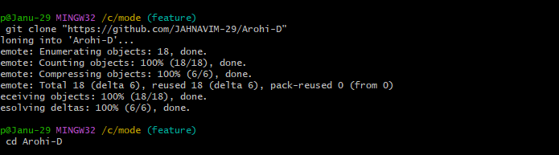

* 1. Make changes to our project files.
  2. Stage and commit changes:

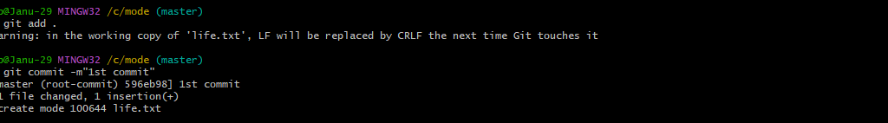

4.Push changes to GitHub:

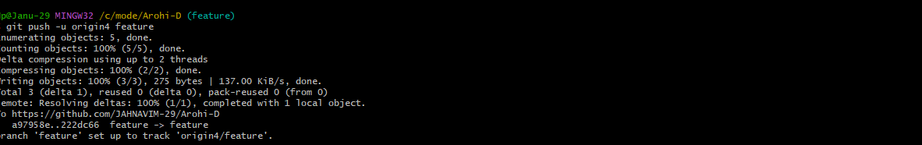

Experiment-04:

• **File Creation With Commit And Push Command.**

➢ To Create a file,commit it and push it to a remote repository using Git Bash

1.Create a File.

Open Git Bash and create a folder :

Using cd and mkdir create a folder:

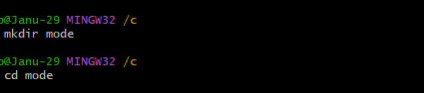

Then git init command to create a new Git repository

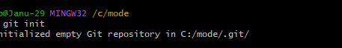

Create a new file using vi command in Linux is used to open and edit files using the vi editor, a powerful text editor available on most Unix-based systems:



Now open the file and write:

Basic vi commands;

* + Insert Mode: o Press **i** to start editing.
  + Save and Exit:
    - * Press ESC then type :wq to save and exit. o Use :q! to exit without saving.

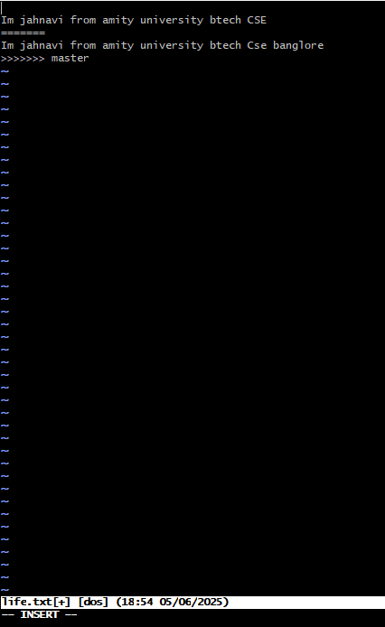

2.Add the File to Git: o Stage the file for commit :



* + - * To add all files in the directory: 

3.Commit the File: o Commit the changes with a message.

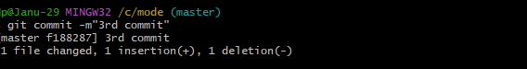

4.Add and push to remote repository:

Push the changes to Git Hub (assuming origin is the remote and main is the branch.)



Experiment-05:

• **Branches Creation**

In Git branches allow developers to work on different features or fixes without affecting the main codebase.Here’s how we can create and manage branches.

* + - Check the branches:

Check the branches using git branch command:

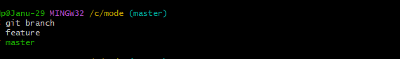

To create new branch ;



* + - Switching to a Branch:

To switch to the newly created branch:

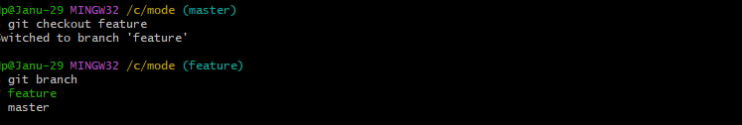

Experiment-06:

• **Merge Request**

o A Merge Request(MR) is a feature used in Gitbased platforms like GitLab to propose and review changes before merging them into the main branch.It is similar to a Pull Request(PR) in GitHub.

How Merge Request Works:

**1. Create a Branch**

A developer creates a separate branch from the main branch (often called main or master) to work on a specific feature, bug fix, or enhancement.

**2. Make Changes**

The developer writes code, commits changes to their branch, and pushes the branch to the remote repository.

**3.Open a Merge Request**

In the Git platform (e.g., GitLab, GitHub):

* The developer opens a **merge request** from their feature branch into the target branch (usually main).
* They add a **description**, possibly link related issues, and assign reviewers.

**4. Code Review**

* **Reviewers** (team members or maintainers) review the code.
* Automated checks (e.g., tests, linters) are run via **CI/CD pipelines**.
* Feedback might be given; the author can make additional commits to address it.

1. **Merge**

The MR is merged into the target branch:

* + - Options include **merge**, **squash and merge**, or **rebase and merge**.
    - Once merged, the feature branch can be deleted if no longer needed.

Steps to Merge the Branch:

1.Switch to the main branch (master):

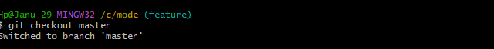

2.Merge the branch:

Using git mergetool and git merge main command:

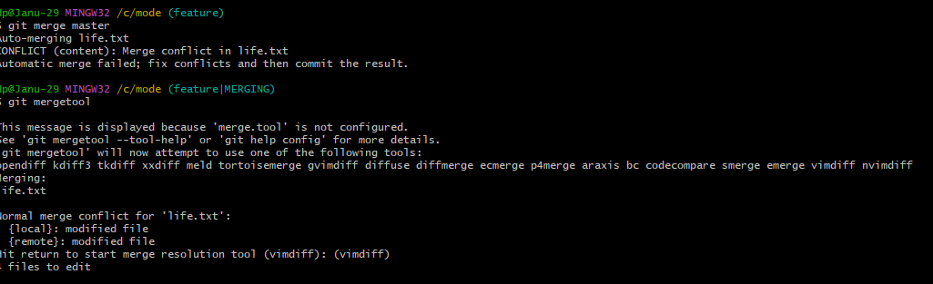

Now Press enter to edit the files and windows are opening ,then remove some red lines and add some lines:

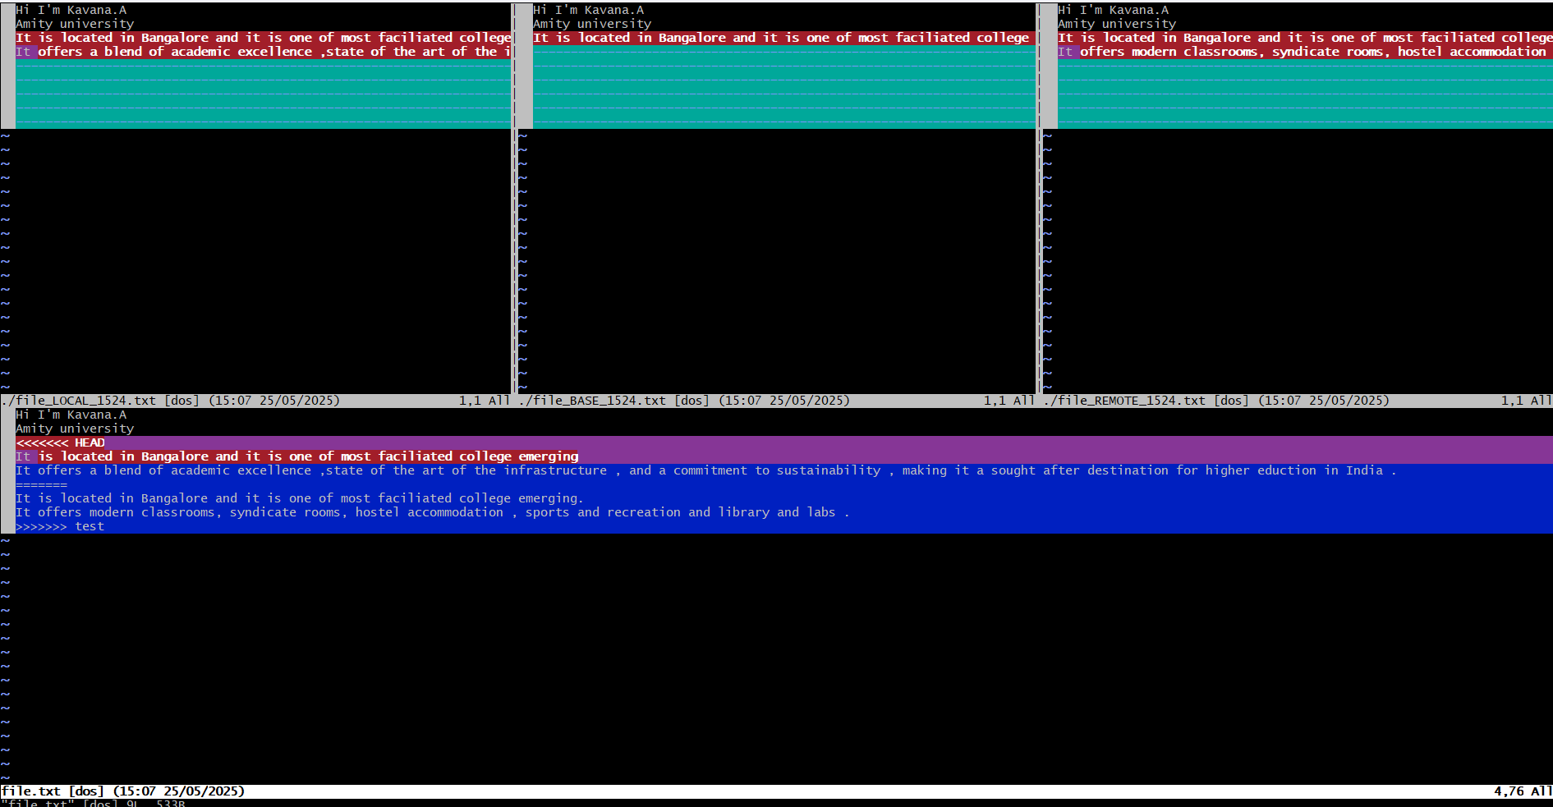

To remove merging commit one line:



Using the command graph we can see the graph of commits:

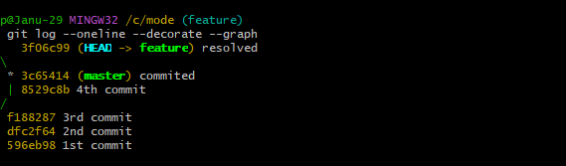

**Benefits:**

* + - Facilitates **code review**
    - Triggers **automated tests**
    - Maintains a clear **change history**
    - Encourages **collaborative development** Experiment-07:
    - **Open and Close Pull Request**

**1. Open a Pull Request**

* + 1. Push your changes to a branch on your fork or the same repository.
    2. Go to GitHub, navigate to the repository.
    3. You’ll see a “Compare & pull request” button — click it.
    4. Add a title and description for your PR.
    5. Click “Create pull request”.

**2. Close a Pull Request**

* 1. Click **“Merge pull request”**.
  2. Confirm by clicking **“Confirm merge”**.
  3. Optionally, delete the branch.

In the git hub account select the user which whom you want to merge and select the repo and fork it:

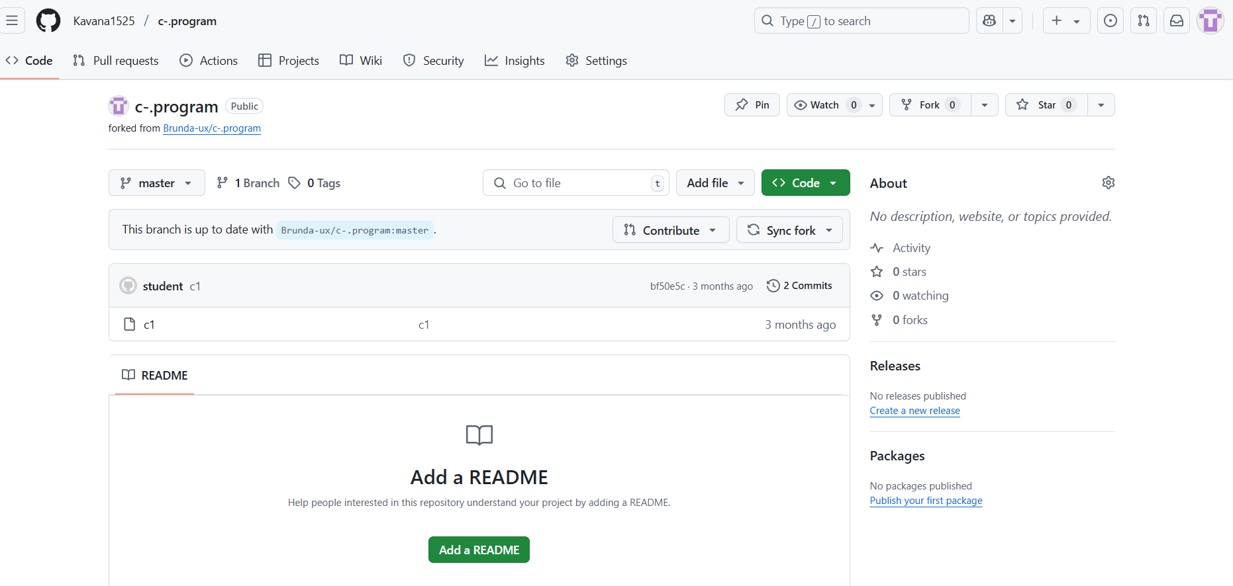

Now copy the link and using git clone command open that file:

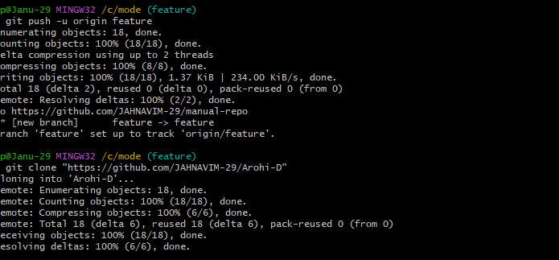

In the Git Hub account contribute to open the pull request:

**Steps to Close a Pull Request on GitHub:**

1. **Go to the repository** on GitHub. 2. Click on the **"Pull requests"** tab.

* 1. Find the pull request you want to close and click on it.
  2. Scroll to the bottom of the PR page.
  3. Click the **“Close pull request”** button.

Experiment-08:

• **Complete Git Process.**

1. Install Git Bash

* + - * + Download Git for Windows from Git's official website.
        + Run the installer and follow the setup instructions.
        + Choose Git Bash as the default terminal option.

2.Initialize a Repository

* + - Open Git Bash and navigation to our project folder.

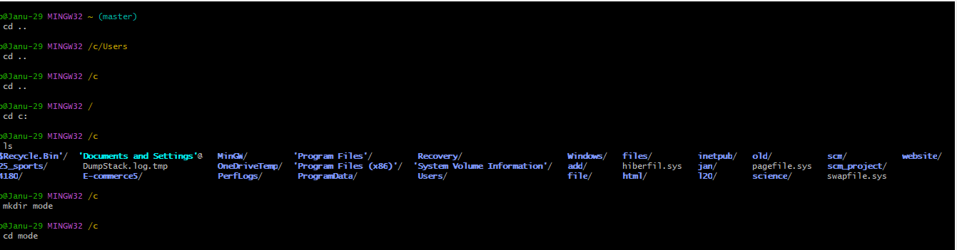

* + - Initialize a new git repository

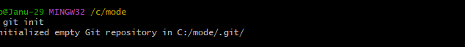

3.Create and Modify Files

* + - Create a file using vi command:



4.Check Repository Status

* + - View changes

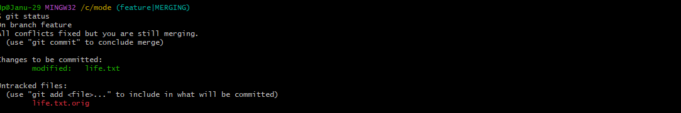

* 1. Stage and Commit Changes
     + Add files to the staging area
     + 
     + Commit changes:

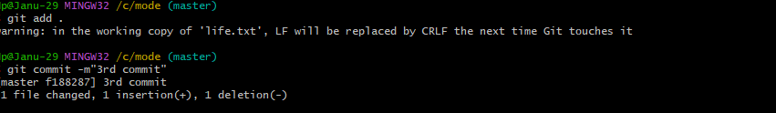

1. Create and Manage Branches

• Create a new branch:



* + Switch to the branch:

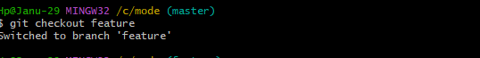

* + Merge the branch into the mainbranch:





Git Clone:

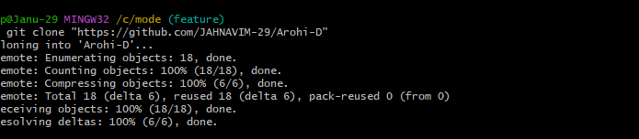

1. Pull Changes from Remote Repository

• Update local repository:

8. Pull Changes from Remote Repository

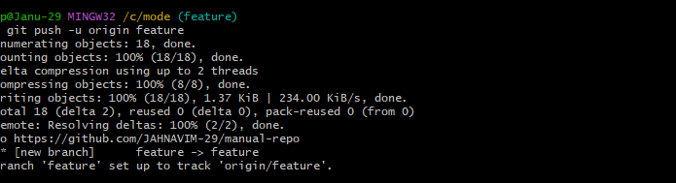

10.Open and Close Pull Requests

* + - Open a Pull Request on GitHub and merge changes.
    - Close the Pull Request if needed

